**Assignment: Data Types**

Brandon Trinkle

Arizona State University

IFT 300

Professor Ashish Gulati

12/1/2024

**Assignment: Data Types**

1. Write a SELECT statement that returns four columns based on the InvoiceTotal column of the Invoices table.

/*

** Author: Brandon Trinkle

** Course: IFT/300

** SQL Server Version: Microsoft SQL Server 2012 (SP1)

** OS : Windows

** History

** Date Created Comments

** 12/1/2024

*/

SELECT

CAST(InvoiceTotal AS DECIMAL(10,2)) AS DecimalValue,

CAST(InvoiceTotal AS VARCHAR) AS VarcharValue,

CONVERT(DECIMAL(10,2), InvoiceTotal) AS ConvertedDecimalValue,

CONVERT(VARCHAR, InvoiceTotal, 1) AS ConvertedVarcharStyle1

FROM Invoices;

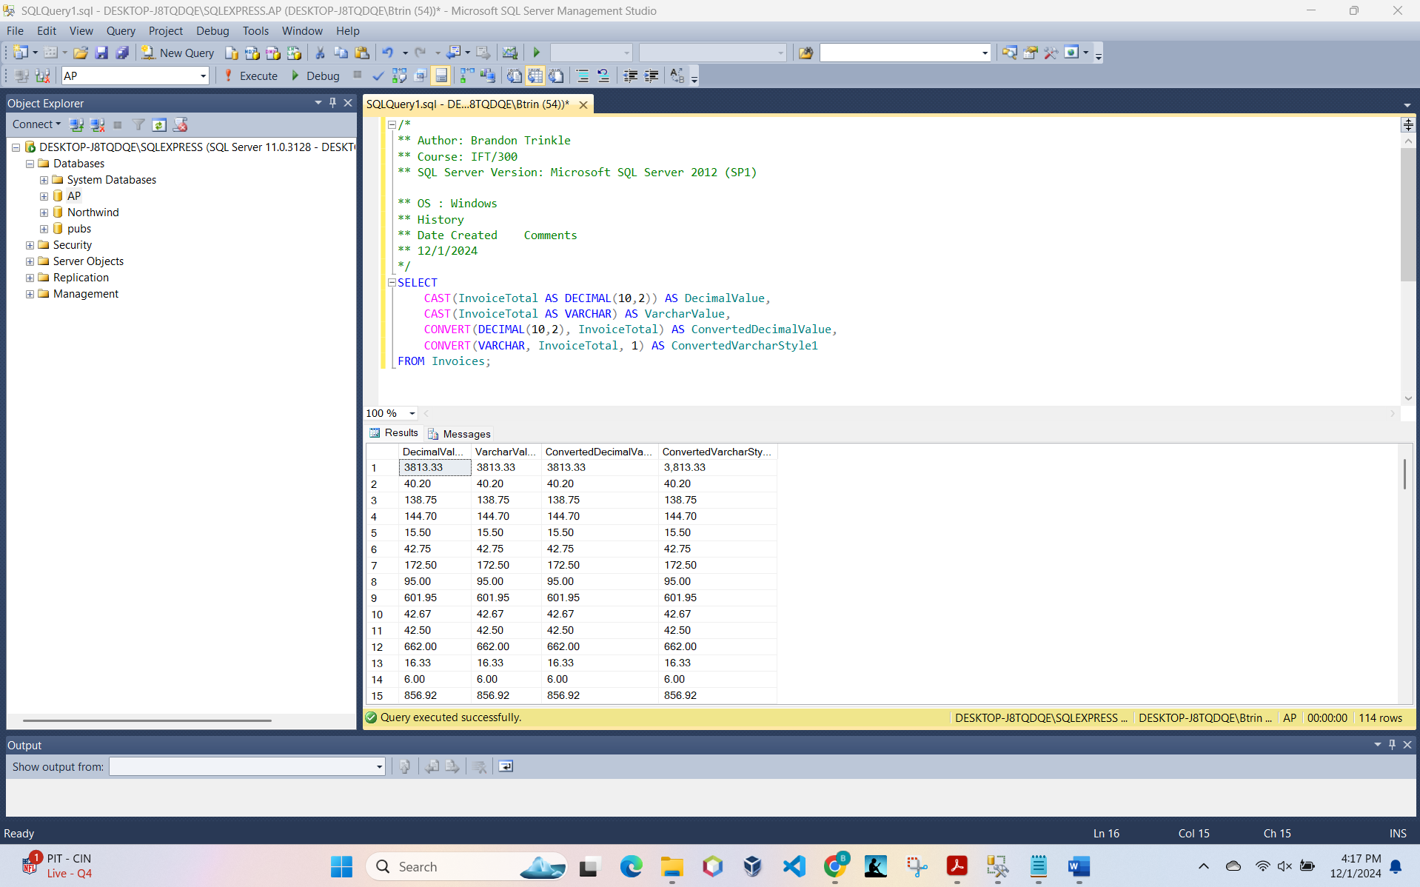

1. Write a SELECT statement that returns three columns based on the InvoiceDate column of the Invoices table.

/*

** Author: Brandon Trinkle

** Course: IFT/300

** SQL Server Version: Microsoft SQL Server 2012 (SP1)

** OS : Windows

** History

** Date Created Comments

** 12/1/2024

*/

SELECT

CAST(InvoiceDate AS VARCHAR) AS VarcharDate,

TRY_CONVERT(VARCHAR, InvoiceDate, 1) AS ConvertedDateStyle1,

TRY_CONVERT(VARCHAR, InvoiceDate, 10) AS ConvertedDateStyle10

FROM Invoices;

